Macintosh HD:Users:Brian:Desktop:Screen Shot 2014-01-09 at 5.57.02 PM.png



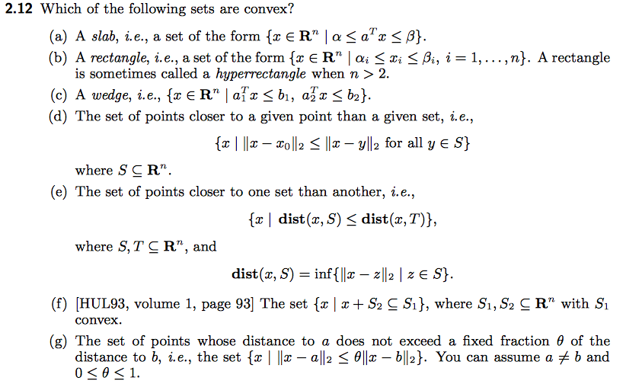

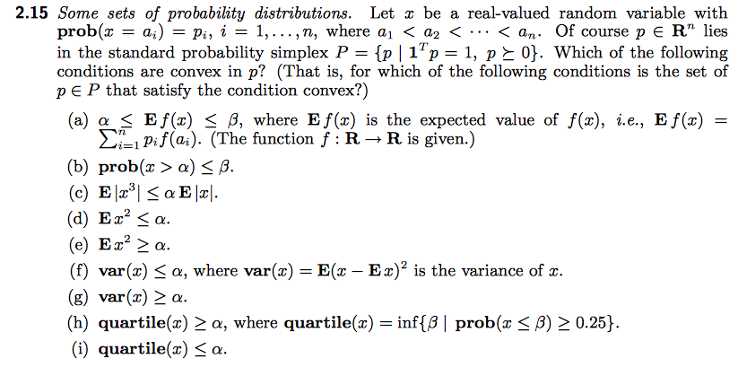

Macintosh HD:Users:Brian:Desktop:Screen Shot 2014-01-09 at 5.58.07 PM.png

